Kubernetes Practice referred by Naresh Sir .

Container Orchestration

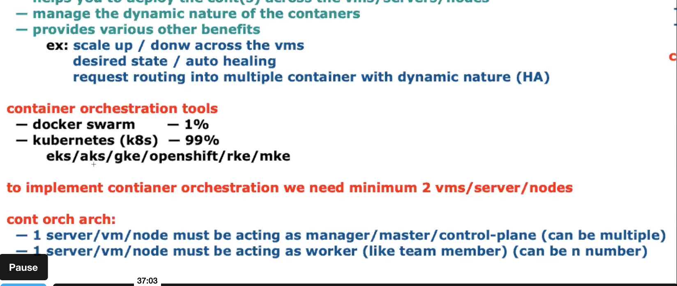

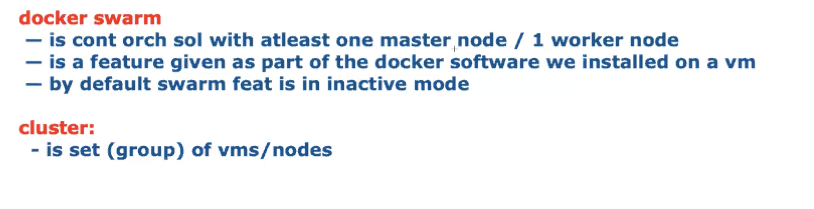

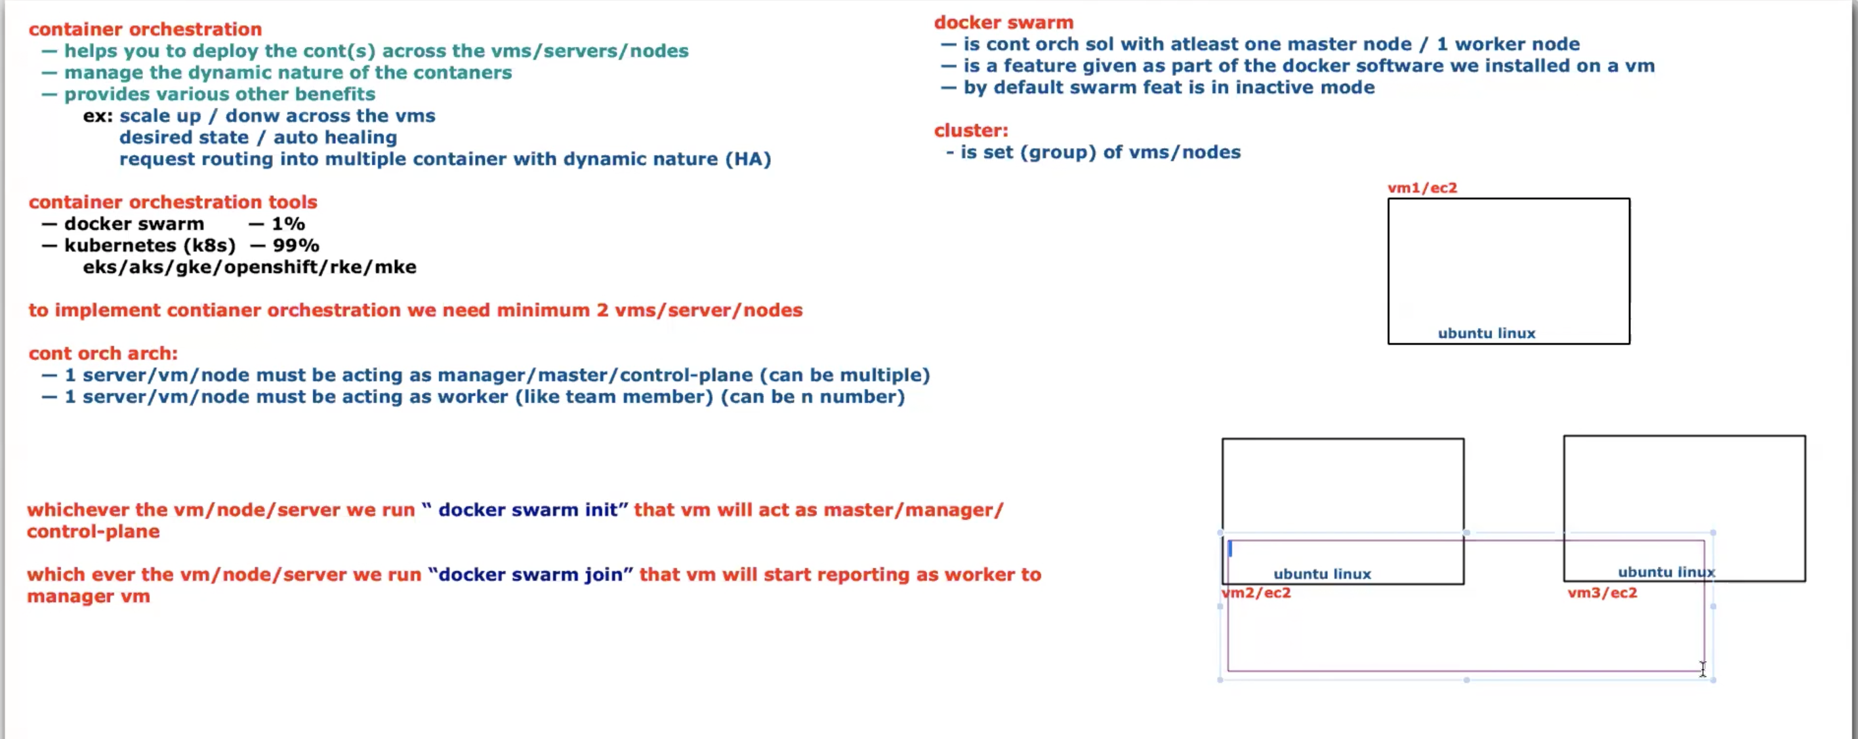

We have Launched 3 VM Ec2 Instacnes

One is Master Node and two are worker nodes

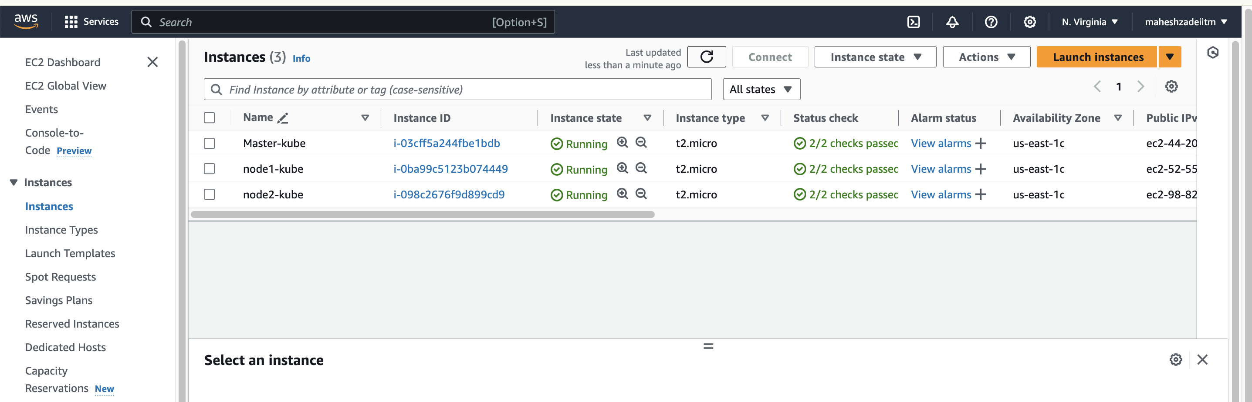

Docker installation is mandatory in all the three nodes

ubuntu@ip-172-31-90-79:~$ history

1 sudo wget https://raw.githubusercontent.com/lerndevops/labs/master/scripts/installDocker.sh -P /tmp

2 sudo chmod 755 /tmp/installDocker.sh

3 sudo bash /tmp/installDocker.sh

4 sudo apt-get update

5 sudo usermod -aG docker ubuntu

6 docker –version

Docker version checked in all the three EC2 Instances after the completion of the installation

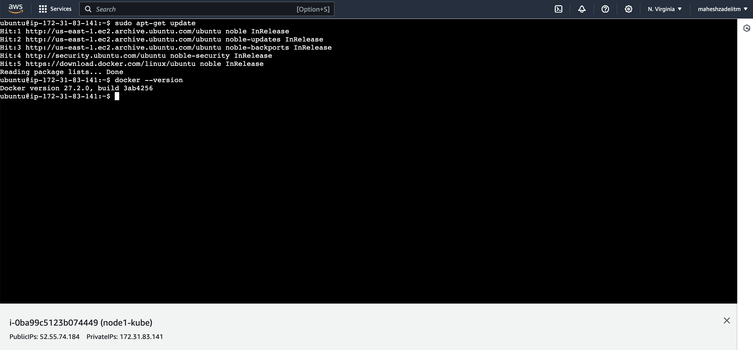

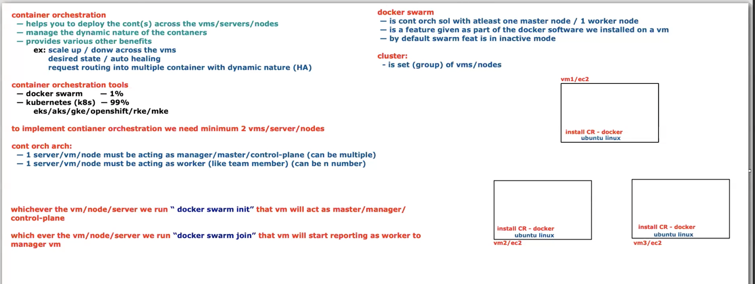

Check docker info command

ubuntu@ip-172-31-90-79:~$ docker info

Client: Docker Engine - Community

Version: 27.2.0

Context: default

Debug Mode: false

Plugins:

buildx: Docker Buildx (Docker Inc.)

Version: v0.16.2

Path: /usr/libexec/docker/cli-plugins/docker-buildx

compose: Docker Compose (Docker Inc.)

Version: v2.29.2

Path: /usr/libexec/docker/cli-plugins/docker-compose

Server:

Containers: 0

Running: 0

Paused: 0

Stopped: 0

Images: 0

Server Version: 27.2.0

Storage Driver: overlay2

Backing Filesystem: extfs

Supports d_type: true

Using metacopy: false

Native Overlay Diff: true

userxattr: false

Logging Driver: json-file

Cgroup Driver: systemd

Cgroup Version: 2

Plugins:

Volume: local

Network: bridge host ipvlan macvlan null overlay

Log: awslogs fluentd gcplogs gelf journald json-file local splunk syslog

Swarm: inactive

Runtimes: io.containerd.runc.v2 runc

Default Runtime: runc

Init Binary: docker-init

containerd version: 472731909fa34bd7bc9c087e4c27943f9835f111

runc version: v1.1.13-0-g58aa920

init version: de40ad0

Security Options:

apparmor

seccomp

Profile: builtin

cgroupns

Kernel Version: 6.8.0-1012-aws

Operating System: Ubuntu 24.04 LTS

OSType: linux

Architecture: x86_64

CPUs: 1

Total Memory: 957.4MiB

Name: ip-172-31-90-79

ID: 60de9305-4a71-4ec4-b0b1-4e419869c0cd

Docker Root Dir: /var/lib/docker

Debug Mode: false

Experimental: false

Insecure Registries:

127.0.0.0/8

Live Restore Enabled: false

In Above command swarm is inactive

Check in node1 as well

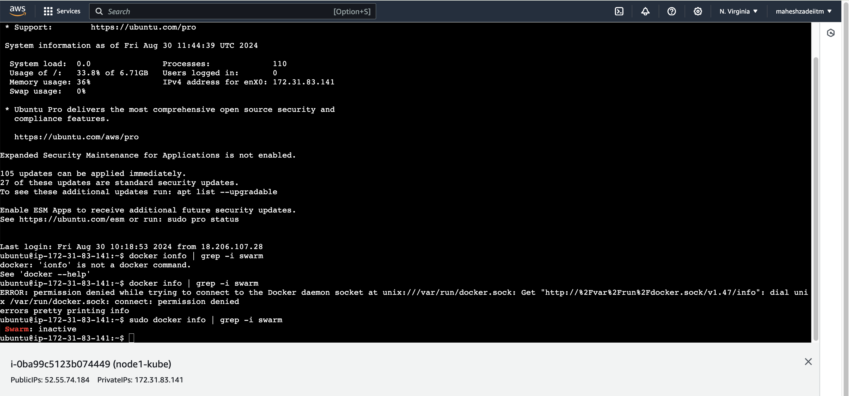

Its showing inactive

Same check in node2

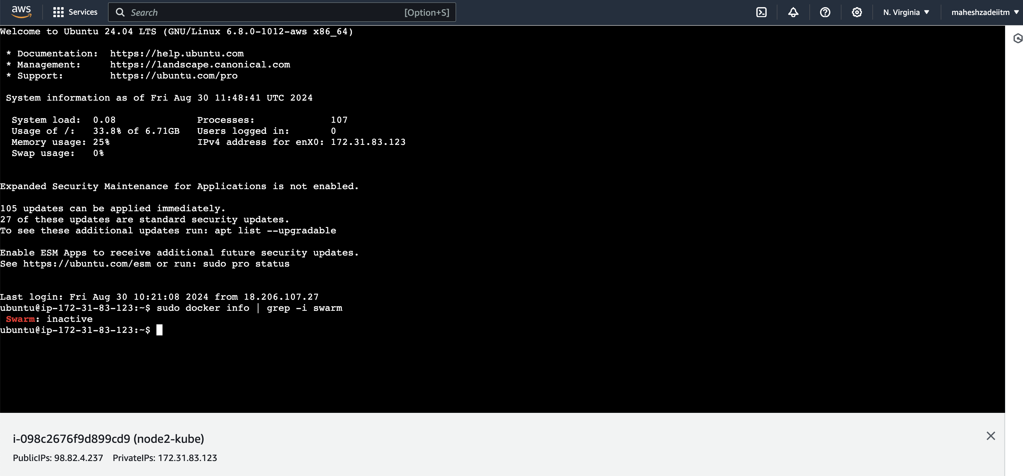

To activate the docker swarm type the below command in master node

Docker swarm init

ubuntu@ip-172-31-90-79:~$ docker swarm init

Swarm initialized: current node (totpngik1l1oo704ppalq5yuh) is now a manager.

To add a worker to this swarm, run the following command:

docker swarm join --token SWMTKN-1-3ox5g0cqdghx1zxlpkz4qbre7hrsozvmngh7w9lysihi8apdin-48f1mmgpxdlnqn7gkc1tasq45 172.31.90.79:2377

To add a manager to this swarm, run 'docker swarm join-token manager' and follow the instructions.

Run the command in both node 1 and node 2

This will show , this node joined a swarm as a worker

Node1

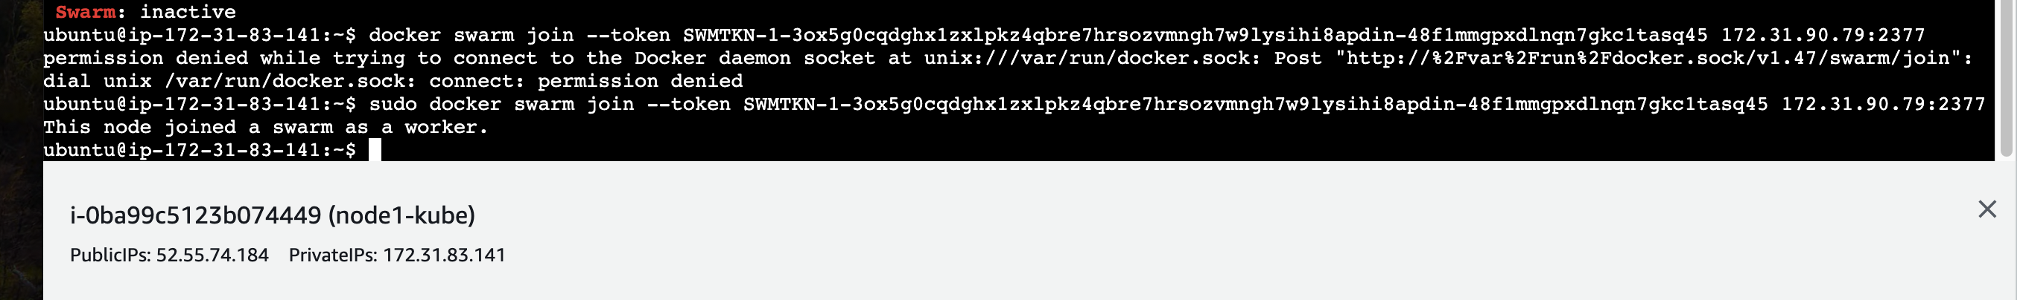

Node 2

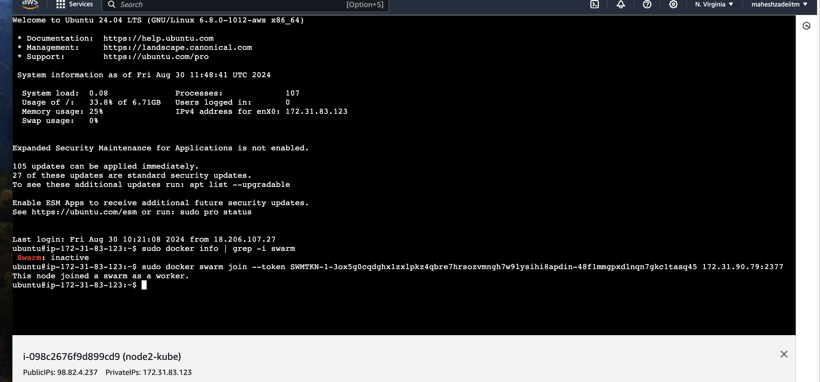

Check the docker swarm ios active by below command in master node

docker info | grep -i swarm

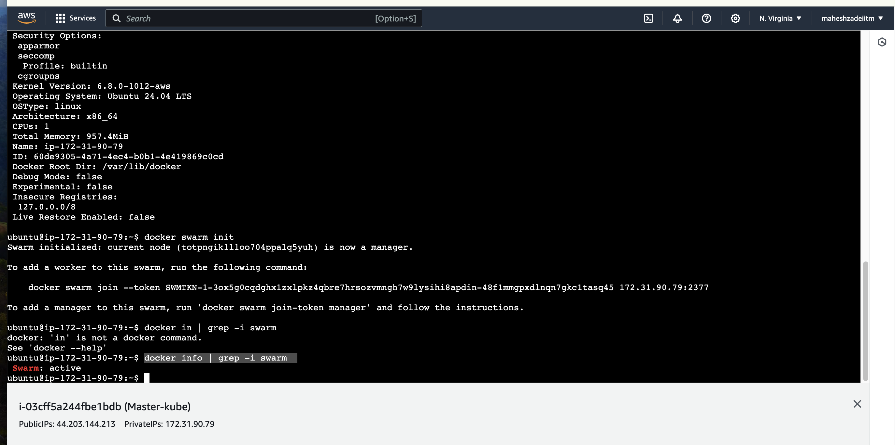

How to check node by the command below

Docker node ls

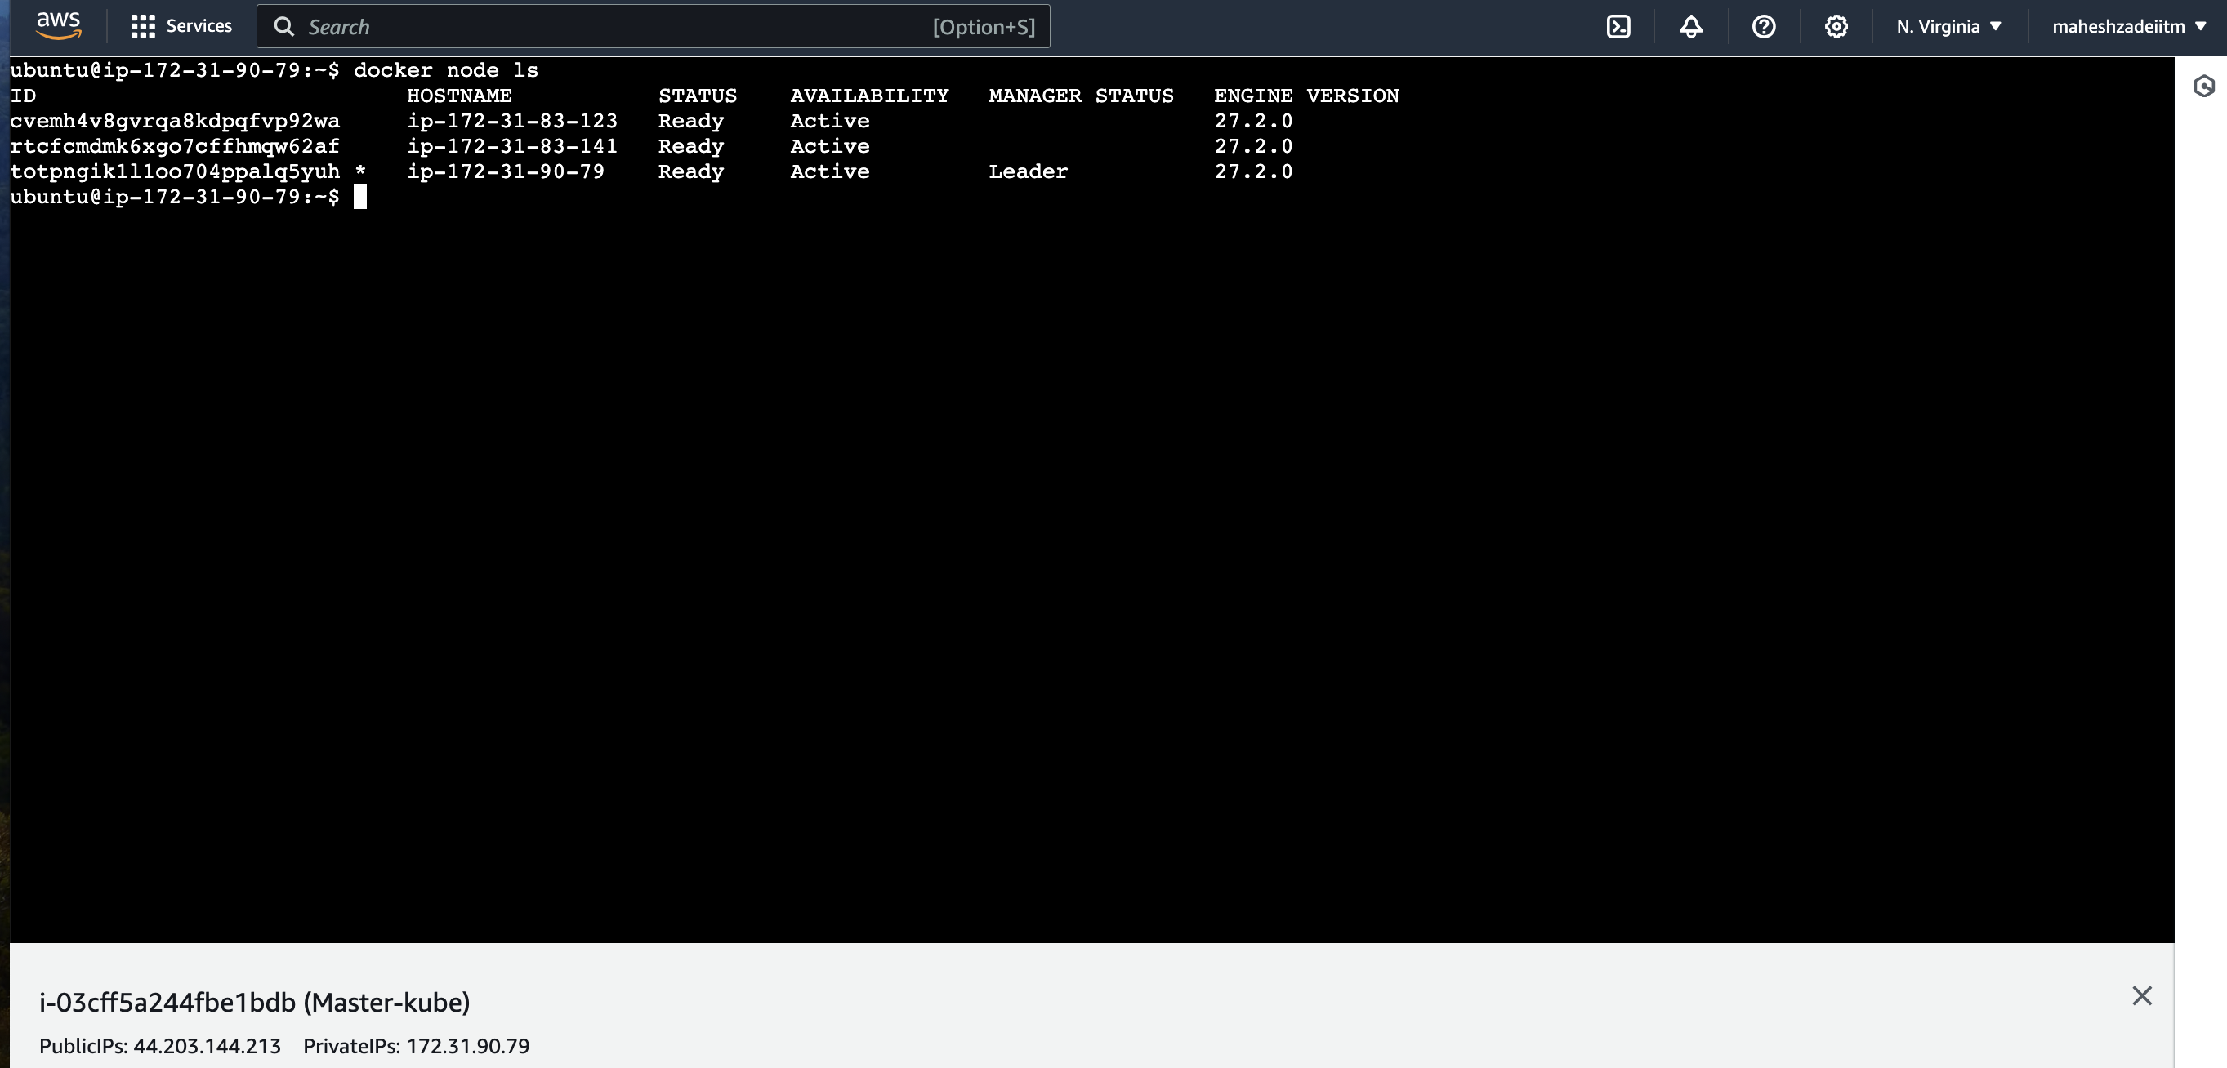

After changing the hostname of all the three EC2 servers

By the command

sudo hostnamectl set-hostname new-hostname

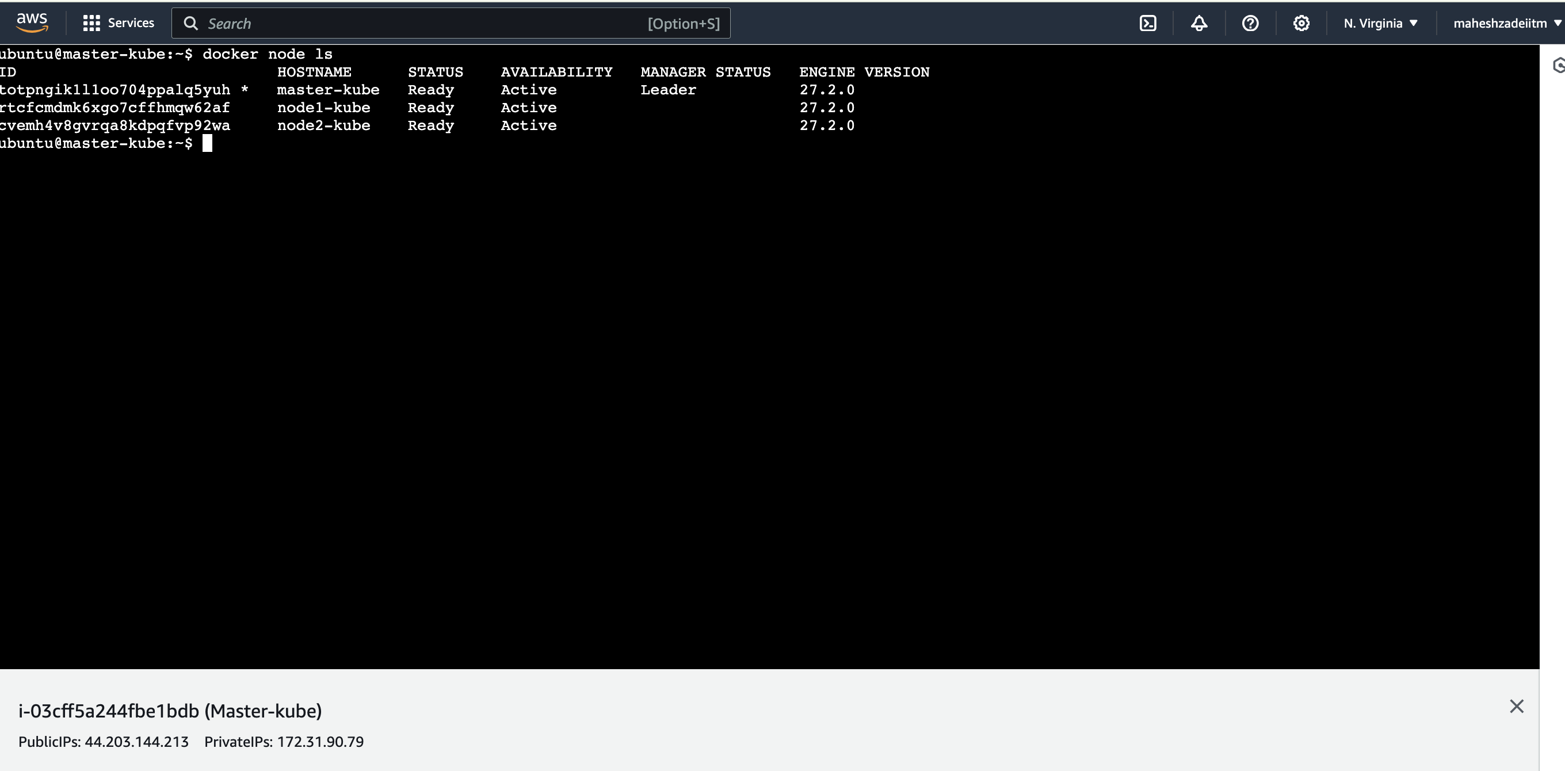

This is called docker swarm cluser / Container orchestration /

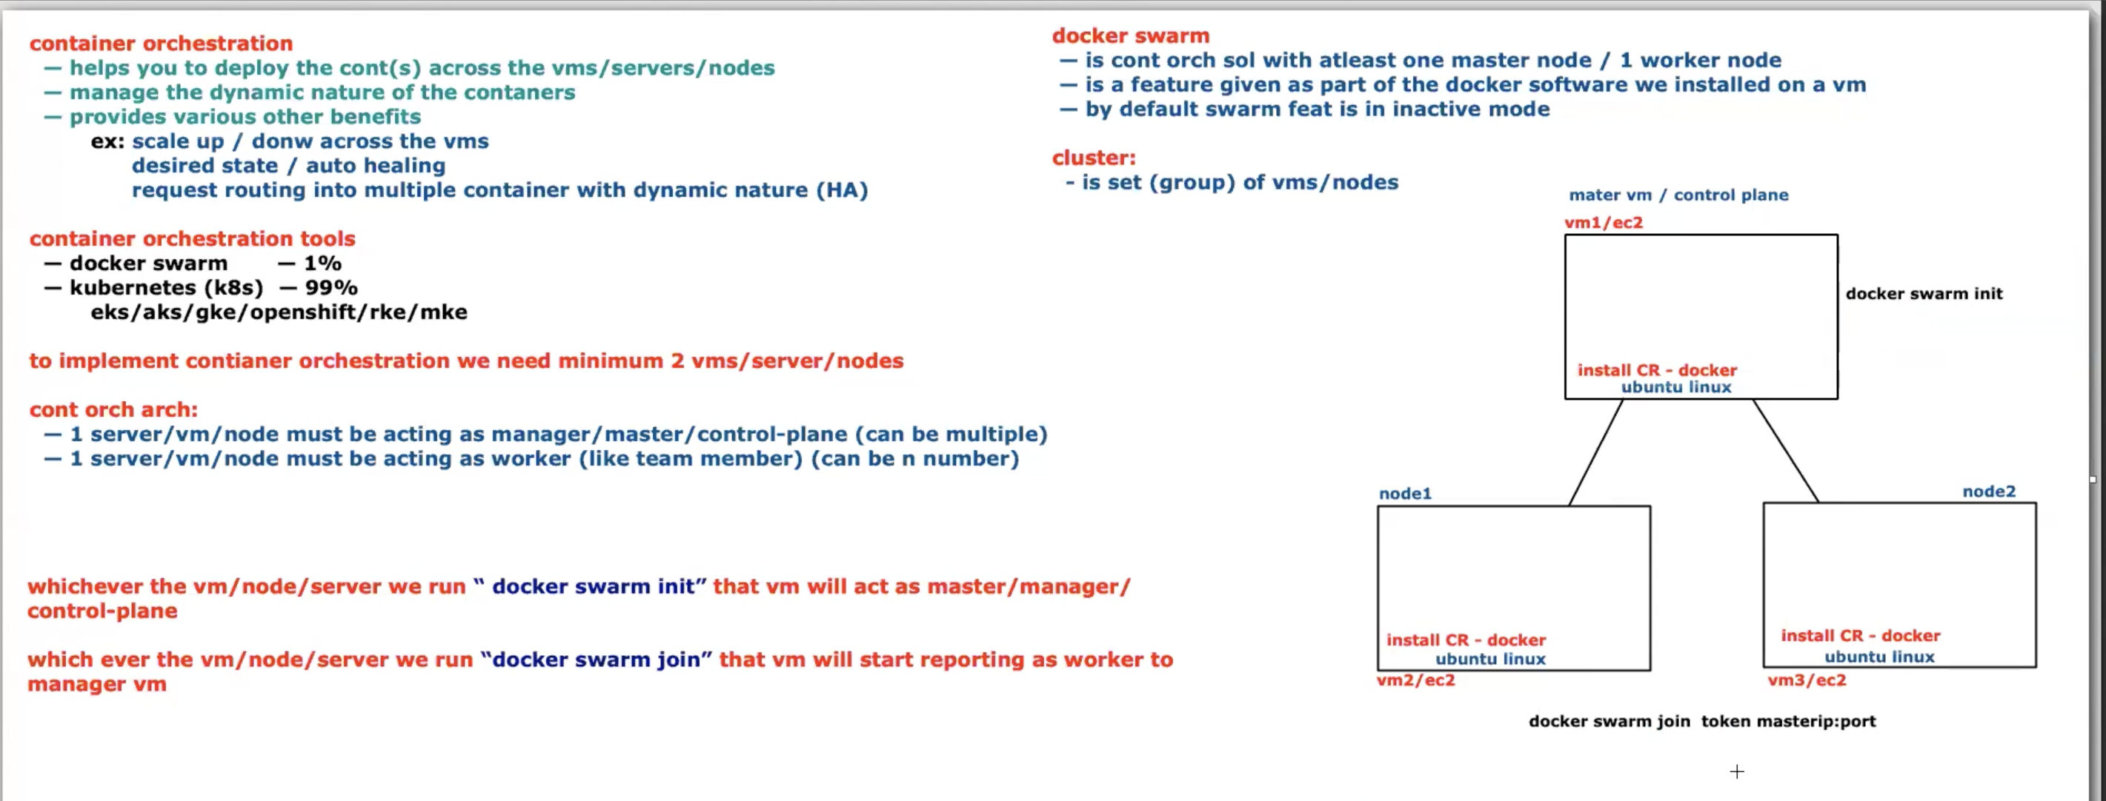

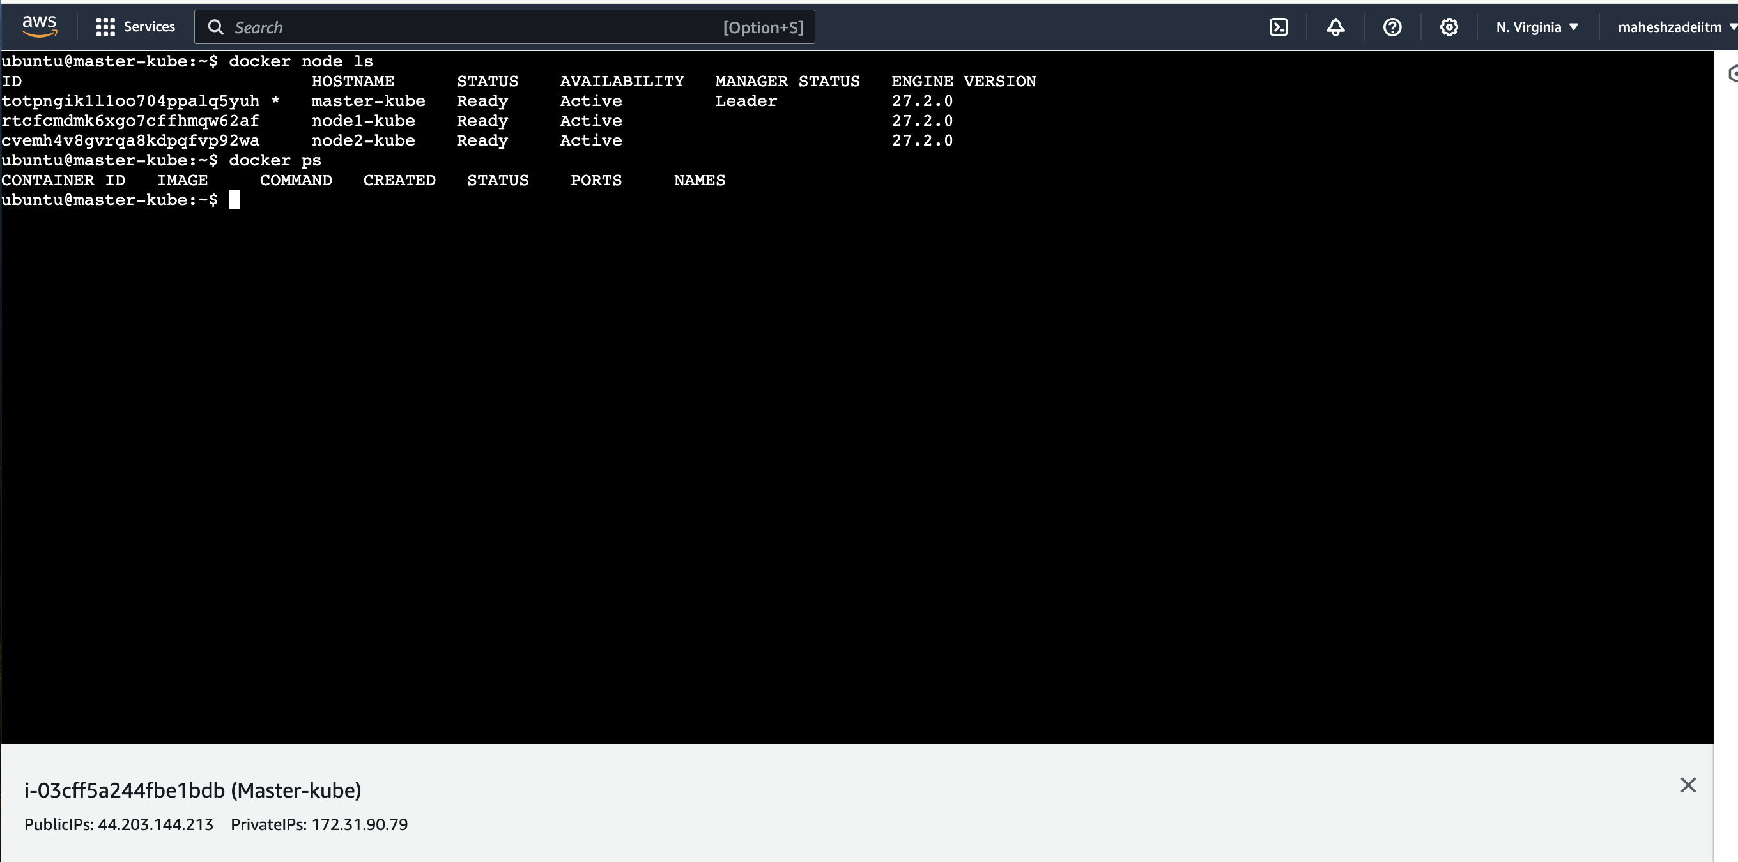

All the three EC2 instacne login in iterm2 terminal

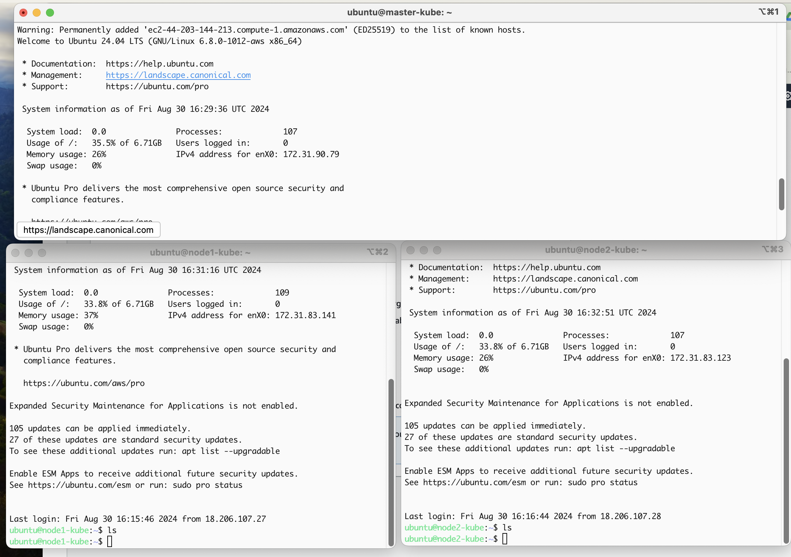

No container is running

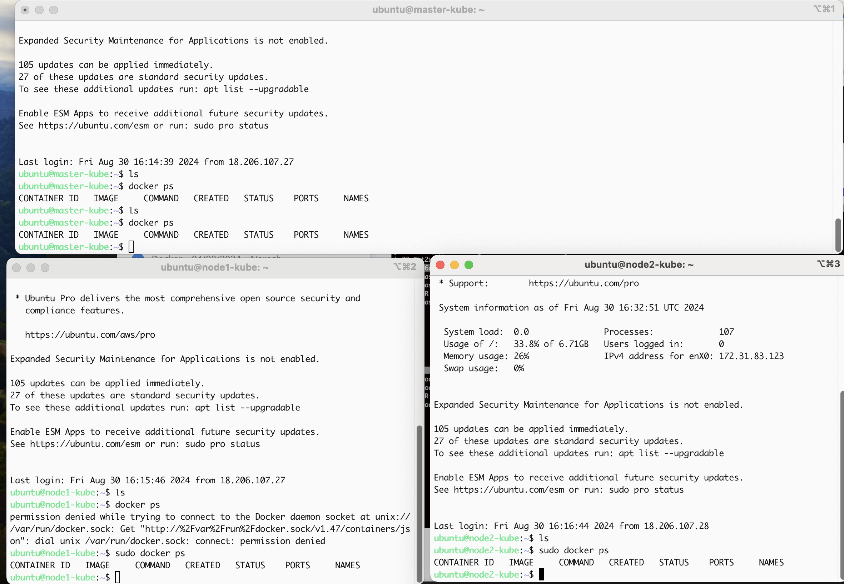

To regenerate the token pls type the below command in master node

ubuntu@master-kube:~$ docker swarm join-token worker

To add a worker to this swarm, run the following command:

docker swarm join --token SWMTKN-1-3ox5g0cqdghx1zxlpkz4qbre7hrsozvmngh7w9lysihi8apdin-48f1mmgpxdlnqn7gkc1tasq45 172.31.90.79:2377

We have deploy multiple manager if one manager goes down

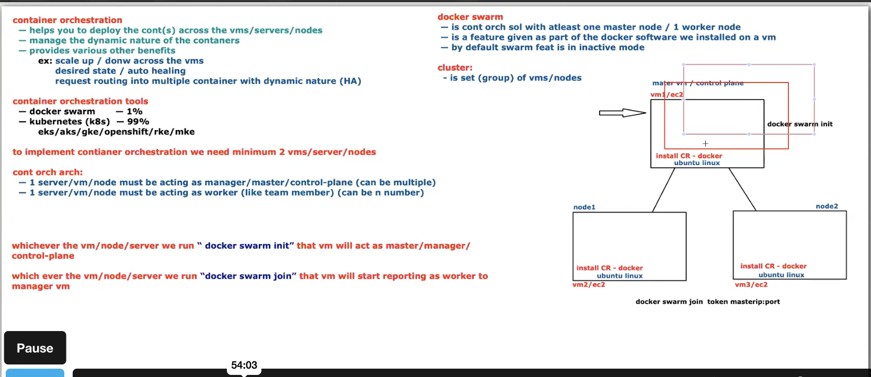

CLUSTER MEANING GROUP OF VM’s

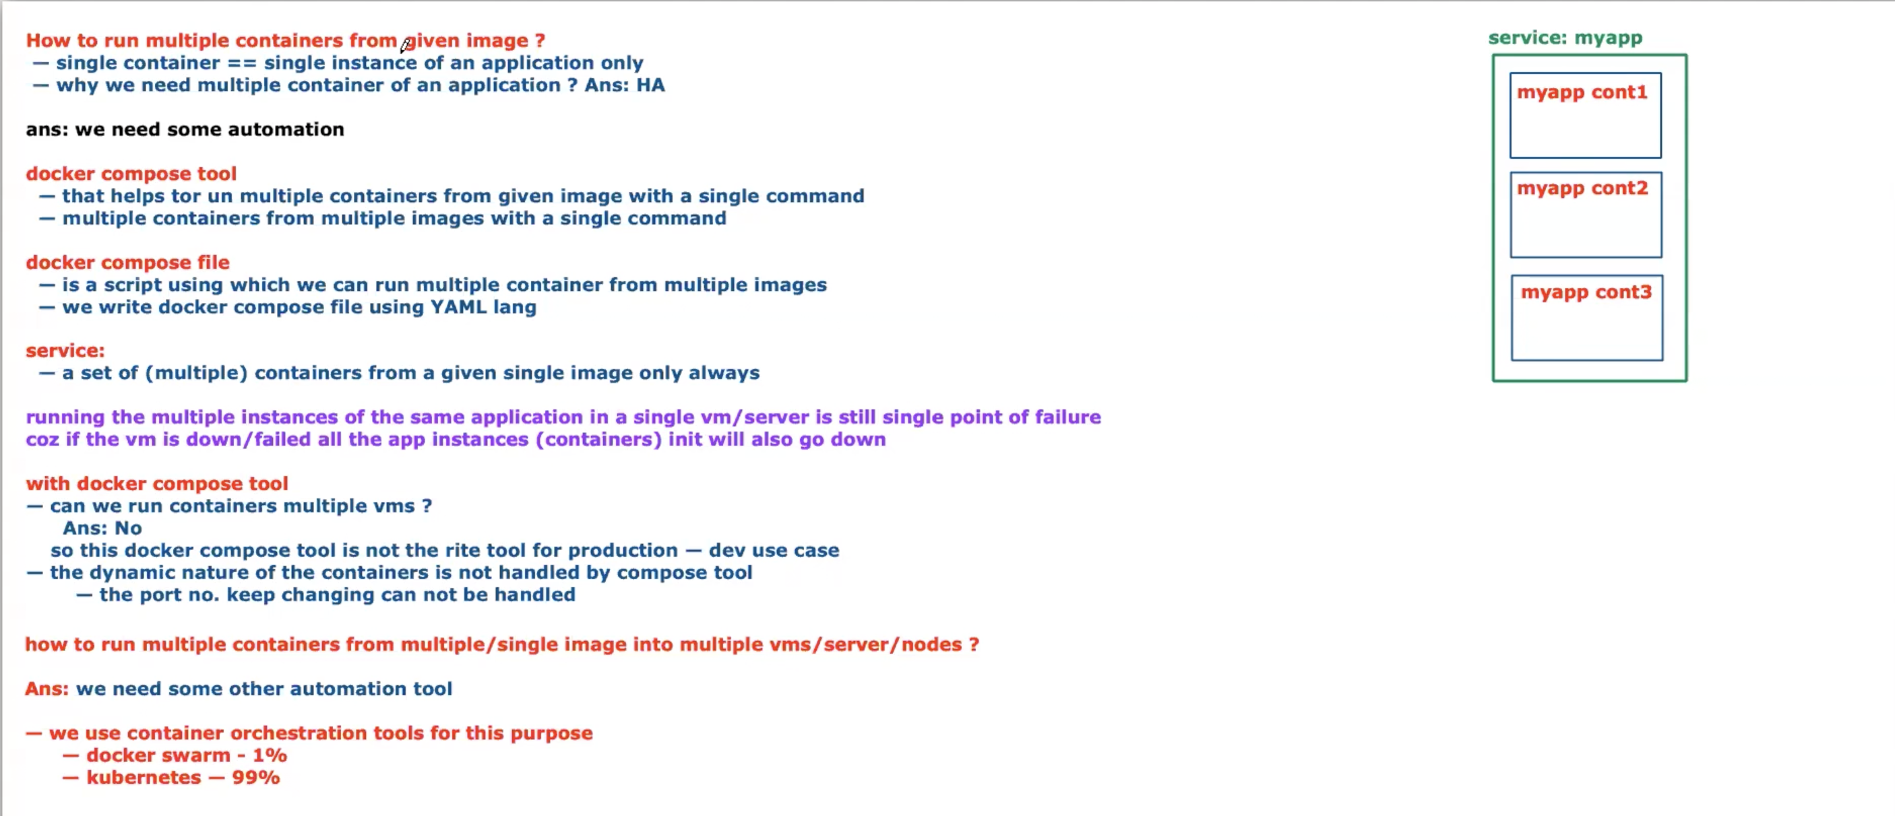

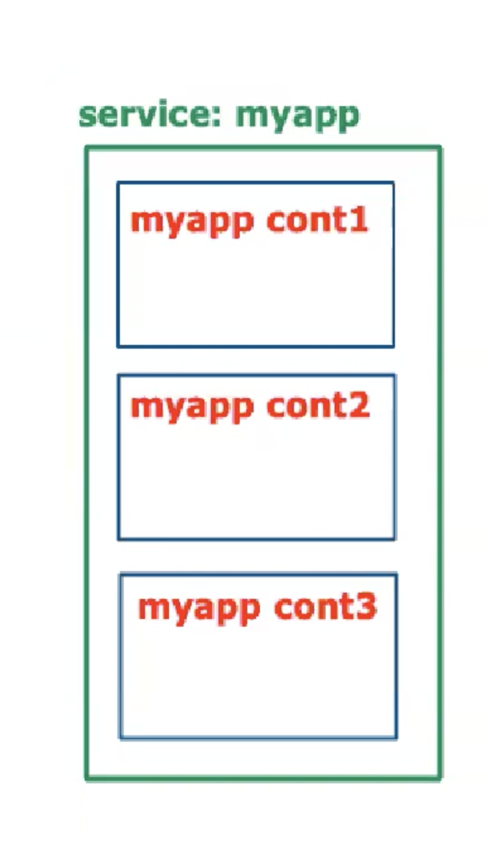

Group of containers above pic

Run the below command to create the multiple container’s in a VM

docker service create --name fbapp replicas 4 -p 9080:3000 lerndevops/samples:pyapp-v1

.